**Home Assistant Installation/User Guide For Raspberry Pi**

**Requires 16 GB SD Card**

**Installation Of Home Assistant**

1. Download and install the Raspberry Pi Imager on your computer as described under <https://www.raspberrypi.com/software/>.

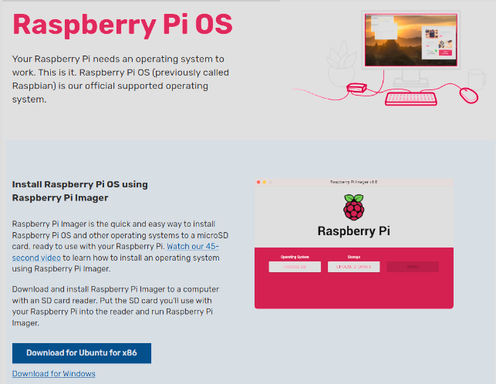

1. Open the Raspberry Pi Imager and select your Raspberry Pi device.

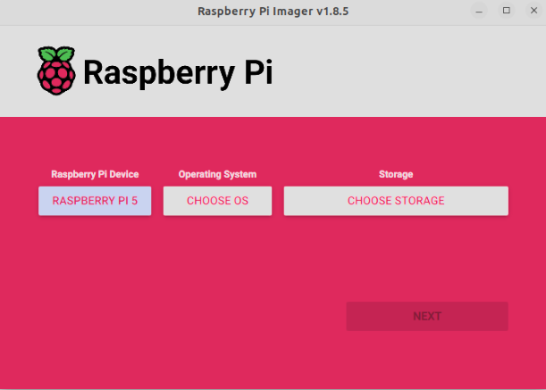

1. Choose the operating system:

* Select **Choose OS**.
* Select **Other specific-purpose OS** > **Home Assistants and Home Automation** > **Home Assistant**.
* Choose the Home Assistant OS that matches your hardware (RPi 3, RPi 4, or RPi 5).

1. Select your SD card:

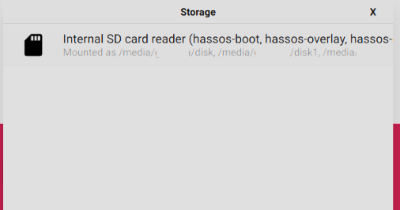

1. Write the installer onto the SD card:

* To start the process, select **Next**.
* Wait for the Home Assistant OS to be written to the SD card

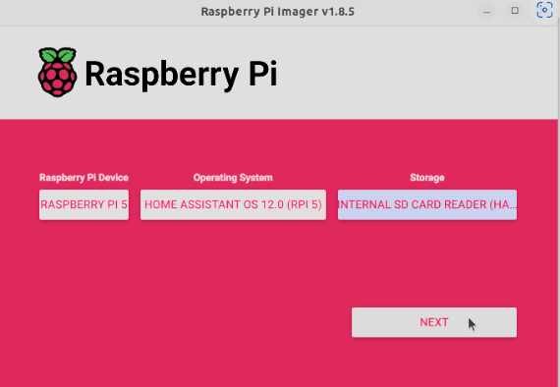

1. Eject the SD card from your computer

**Accessing Home Assistant**

1. Insert the SD card Into Raspberry Pi and power the device

* Plug in an ethernet cable from your router to Raspberry Pi
* Make sure the computer you are using is connected to the same router via an ethernet cable

1. In the browser of the computer connected to the same router as the Raspberry Pi, enter [homeassistant.local:8123](http://homeassistant.local:8123/)

* Within a few minutes after connecting the Raspberry Pi, the website above should prompt you to create a home assistant account
* After creating the account your home assistant should look similar to this 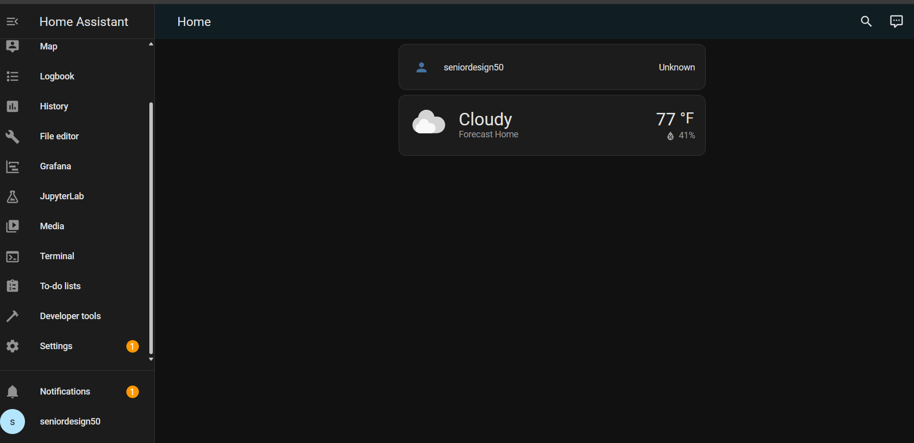
* If nothing pops up after a few minutes on [homeassistant.local:8123](http://homeassistant.local:8123/) try flashing the SD card again or use a different card. Visit [Raspberry Pi - Home Assistant (home-assistant.io)](https://www.home-assistant.io/installation/raspberrypi) for FAQ and guide.